DSCI 551 COURSE PROJECT, SPRING'26
Phase 2: Midterm Report and Implementation Checkpoint

Group Members
Chanyoung Kim
Yogita Mutyala



Chosen Database System and Motivation
Database System: PostgreSQL 18.1 with Apache AGE 1.7.0. In the domain of financial fraud detection, transactional data benefits from the ACID guarantees of a relational DBMS, while suspicious money flows often require relationship-oriented analysis. The motivation of this project remains the same as in the proposal: to evaluate whether a graph-on-relational approach can support AML analysis without maintaining separate relational and graph database systems.
At the midterm checkpoint, the implementation runs inside a Docker container named apache-age. The system includes relational tables for customers, accounts, and transactions, a synthetic workload generator, a SQL-based smurfing detector, and an AGE graph named aml_graph that mirrors account-transfer relationships.
This differs from a native graph database because the authoritative transaction data still lives inside PostgreSQL heap tables, and it differs from plain PostgreSQL because AGE adds graph labels, Cypher queries, and edge-based traversal over the same workload.
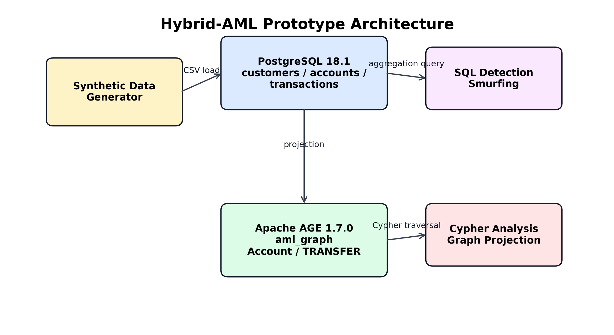
Figure 1. Midterm prototype architecture.
Research Question
The research question from the proposal remains unchanged: can PostgreSQL with Apache AGE efficiently support graph-oriented fraud analysis compared with native relational approaches, and what storage and execution tradeoffs appear in this hybrid model?
Planned Internal Focus Areas and Motivation
Focus Area 1 is storage architecture. At this stage, the relational schema has been implemented, and the same data has been projected into AGE as Account vertices and TRANSFER edges. Focus Area 2 is query execution. The current checkpoint demonstrates a working SQL aggregation query for smurfing detection and the successful graph materialization needed for later Cypher-based traversal analysis.
Focus Area | Midterm Status
Storage Architecture | customers/accounts/transactions schema implemented; aml_graph projection loaded
Query Execution | SQL smurfing detection verified; planning time 0.673 ms; execution time 0.139 ms
Evaluation Metrics
The evaluation metrics remain query latency, planner cost, storage overhead, throughput under synthetic workload, and index effectiveness. The current checkpoint provides the first latency evidence through SQL execution planning and runtime. The measured planning time for the smurfing query is 0.673 ms, and the measured execution time is 0.139 ms.
Preliminary Application Idea
Application Name: Hybrid-AML. The application remains a financial monitoring prototype with two target features: smurfing detection and circular trading detection. The implemented checkpoint feature is smurfing detection over a synthetic dataset that contains 33 customers, 38 accounts, and 209 transactions.
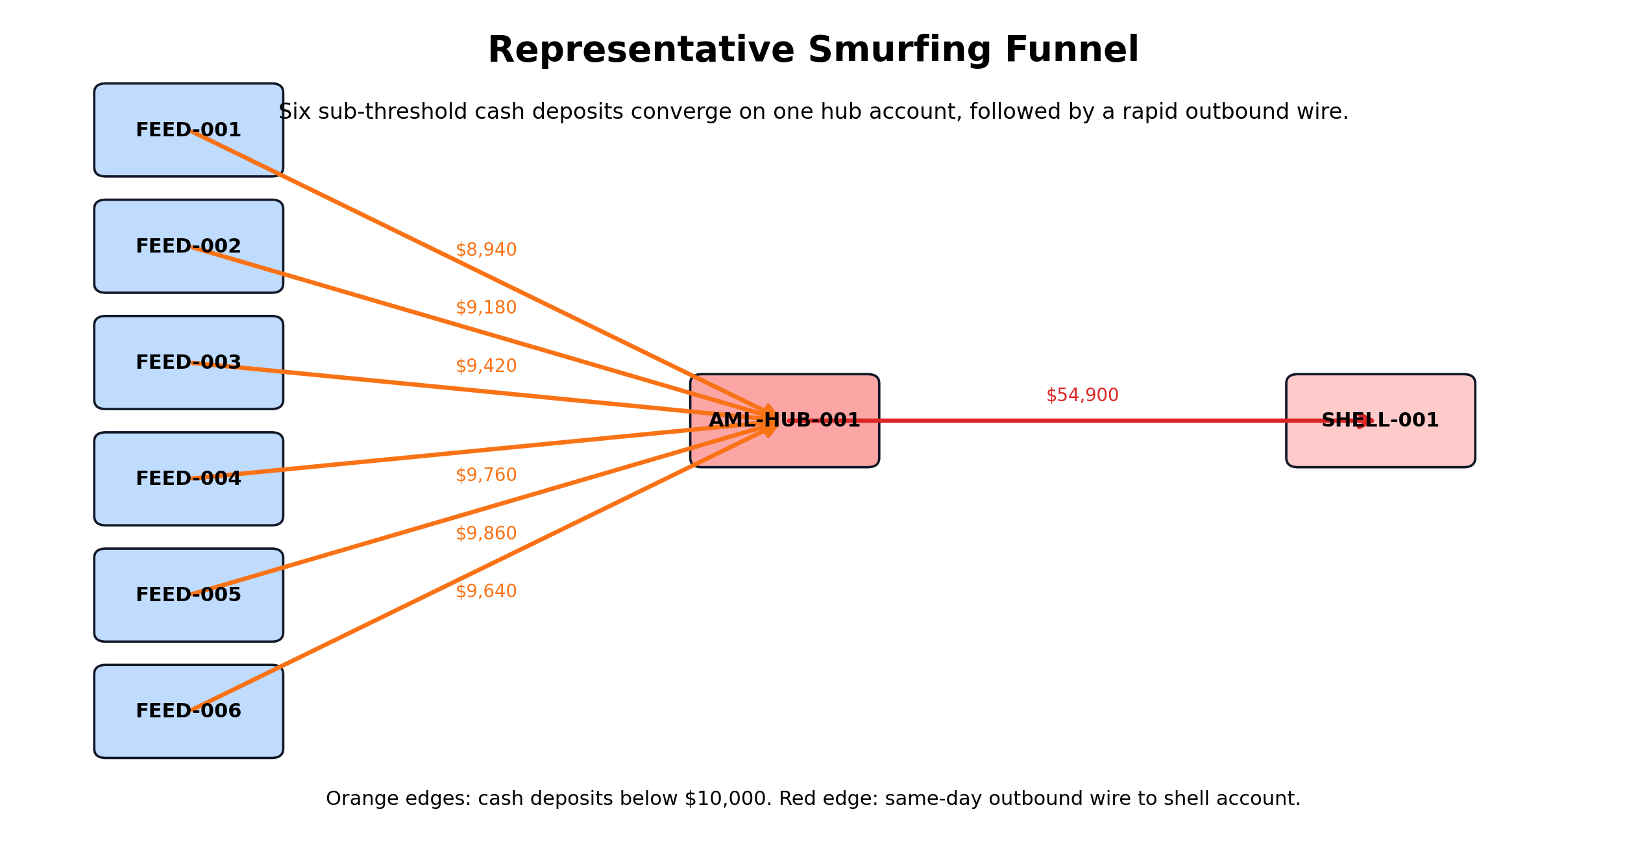
Figure 2. Representative smurfing funnel scenario.
Data Description and Implementation Checkpoint Results
The Docker environment is running, AGE is installed, the schema is loaded, the synthetic dataset is inserted, the SQL detector returns one suspicious funnel, and the AGE graph projection contains all account vertices and transfer edges.
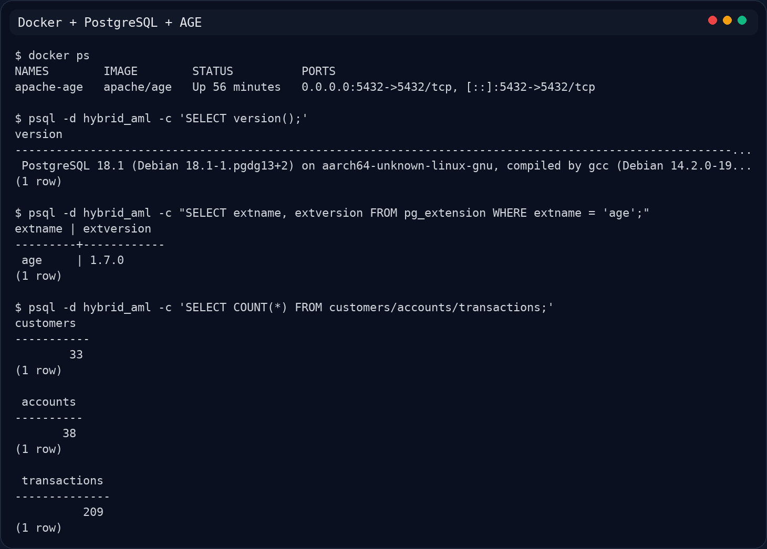
Figure 3. Environment and extension verification.
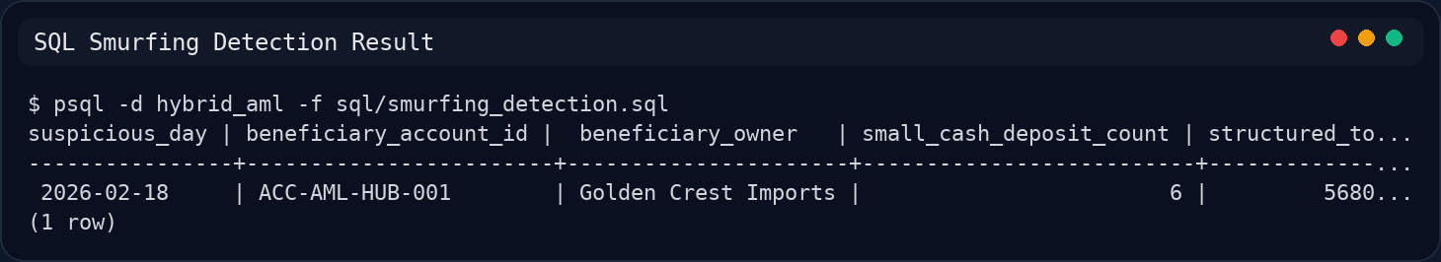
Figure 4. SQL smurfing detection result.
Preliminary Mapping Between DB Internals and Application Behaviors
The smurfing detector groups cash deposits by beneficiary and day, then uses the indexed outbound lookup on transactions(from_account_id, tx_time) to find rapid funnel-out behavior. Because the current dataset is small, PostgreSQL still uses a sequential scan in the initial filtering stage.
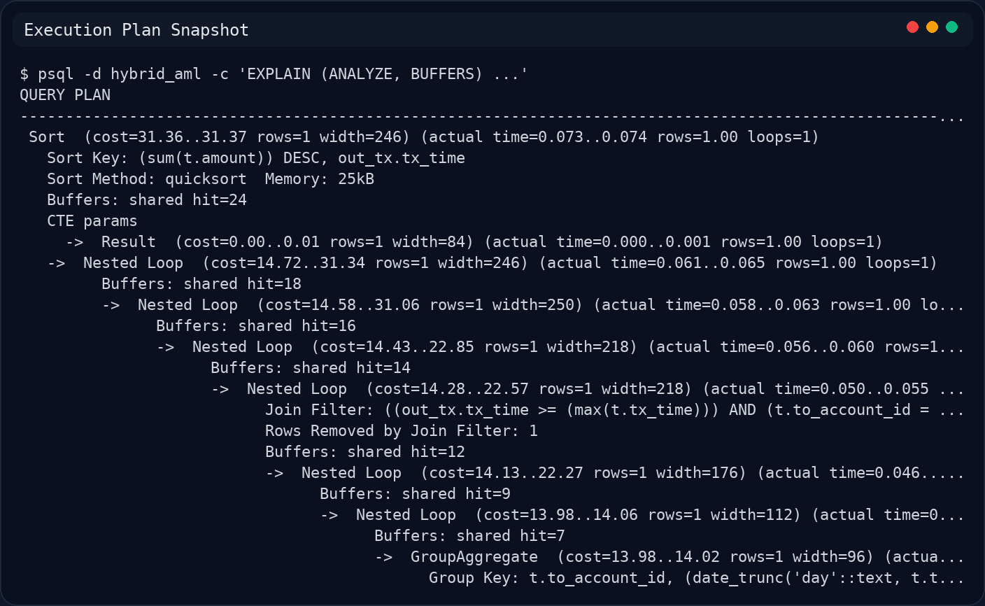
Figure 5. Execution plan snapshot.
The AGE graph projection maps each account to a vertex and each transaction to a TRANSFER edge with amount, time, channel, and fraud-label properties. This preserves the proposal's graph-on-relational design while keeping the relational schema as the authoritative store.
At the current stage, these results do not show that the graph layer is better or faster than the relational approach. The midterm evidence only establishes that the relational feature works and that the graph projection has been loaded successfully. A fair comparison will require circular-trading workloads and side-by-side Cypher-versus-SQL measurements in the next phase.
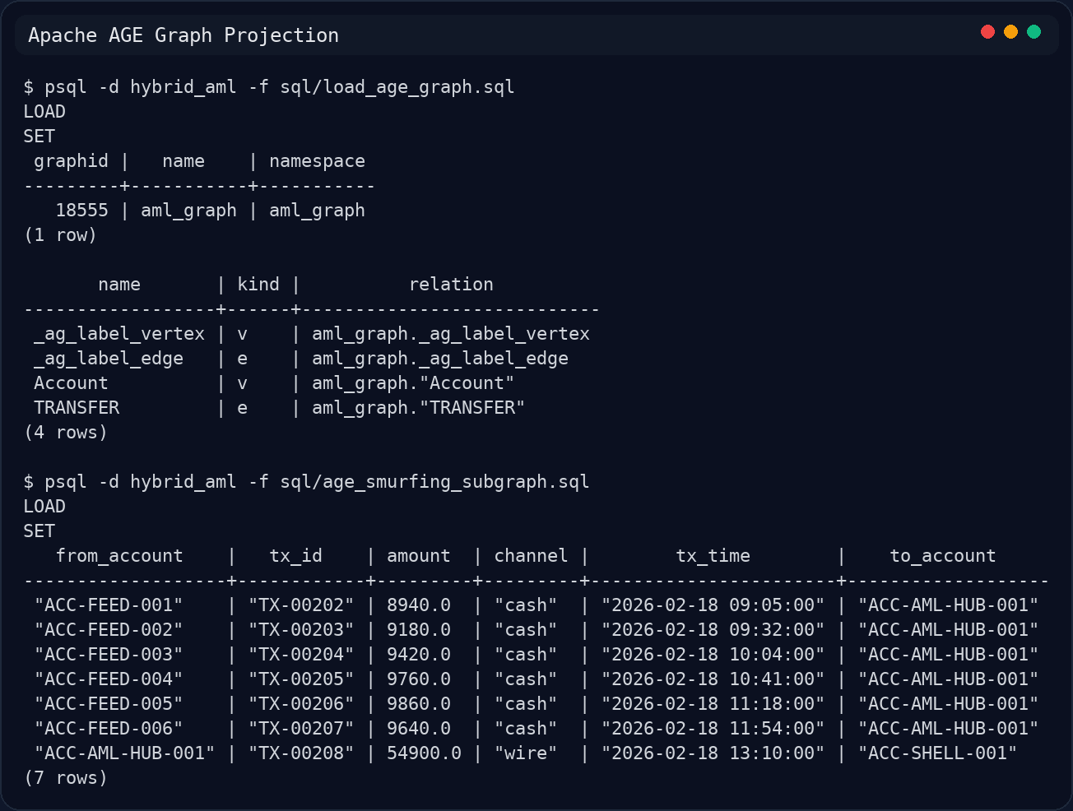
Figure 6. AGE graph projection evidence.
Progress Update and Challenges
Completed work includes Docker setup, schema implementation, synthetic data generation, SQL smurfing detection, and the initial AGE graph load. Remaining work includes circular trading detection, larger workload generation, and a direct Cypher-vs-SQL traversal comparison.
The main challenges are AGE query tuning, workload scaling, and creating cyclic suspicious patterns without losing interpretability for the report.
Initial References
1. Apache AGE Documentation. The Apache Software Foundation. https://age.apache.org/
2. PostgreSQL Global Development Group. PostgreSQL Documentation: Database Physical Storage.
3. Stonebraker, M. The Case for Polystores. IEEE Data Engineering Bulletin.

